Project 1

# Abstract

The buck converter circuit is a DC-DC power step down converter which allows us to go to a lower voltage than the input supply. Due to the nature of components such inductors and capacitors we have very minimal power loss at the output often making it over 85% efficient. Most usage of buck converters comes into play with a linear regulator to step down the voltage even further to a cleaner output so that the heat dissipation is taken care of by the converter while the regulator takes care of the noise. The circuit consists of an inductor, capacitor, and two switches which are typically a transistor and a diode. The switching of the transistor allows the current to flow in from the transistor and also the diode and transistor are complimentary switches of one another. The output power comes from the inductor due to the decreasing current after the turning off of the switch and therefore acting like a current source that is being taken in and out of a circuit. The voltage on the capacitor would exponentially increase if not for the switches due to the current source from the inductor. We shall explore this in further detail.

# Theory

The given voltage input voltage was 480 V and the needed output voltage from the circuit was 48 V. After using the duty cycle formula, we can find that a duty cycle of 1/10 is appropriate to step down to that voltage. Further exploring, the lighter load for the power would be determining our critical inductance value. Since we would not like to be operating in discontinuous mode, we must be sure that the inductance is above the critical inductance. Using the 2 kW dissipation of power, I found the resistor to be 1.152 Ω and using this we can find the critical inductance to be 51.84 µH. The given formula is ${L=1.1*L}_{crit}$. Using this formula, we find the L to be 57.024 µH. Additionally, I find the capacitor value to be above 473 µF using the spec of ΔVload = 2 V and $T_{SW}=\frac{1}{10 kHz}$. Attached to this report is a page consisting of the analytical results of the simulation from hand of the plots of voltages, currents of each respective component. The max and min values for each for been labeled as I_1 and I_2 which were 3.785 A and 79.548 A for the light load while being 378.79 A and 454.55 A for the heavy load. The model was also attempted to be simulated with the non-idealities of the voltage drop across the diode and the transistor however this was not successful due to the output not generating the expected.

# Results

Buck Converter with Inputs of:

L = 57.024e-6; %Inductor

C = 473e-6; %Capacitor

R = 1.152/10; % Rload - HEAVY

D = 1/10; % Duty Cycle

delta_t = (1/10000)/100; %Delta T

initial_I = 378.79; % Initial Inductor Amps

initial_V = 48 + 2; % Initial Capacitor Voltage

* 1. The critical inductance was established in theory section where it was found to be 57.024e-06 µH.
  2. The plotted values for the respective voltages and currents are on the engineering paper.
  3. Switching.m was first created to determine the state of the transistor being on or off using the time input from the user and returning a 1 or 0 depending on state of transistor. Additionally, the logic of the program works in the sense that it defines a very small interval and checks the value of the fourier series against the duty cycle interval to return the state of the transistor. Buck.m calculates the inductor current and the voltage of the capacitor to determine the output voltage. Using a backward euler integration formula, we can approximate the next instant of the current and the needed voltage using a very small time interval and also initializing with the previously determined value. The coefficients for the euler integration were derived in lecture and give us a 2x1 matrix where i[1] = inductor current and i[2] = voltage output. This output of arrays is given to the buckpostproc.m where further derivations of voltages and switches are derived there. Based on the input of the time, we can determine the state of the diode and transistor to get the respective voltages. Essentially, one can multiply by the state of the transistor or diode to determine what would be the final voltage at the end of that sub-cycle.

Starting off with Part C, Part III we find that the initial cycle takes about 2 cycles to fully reach the needed 48 V from 0 V and 0 A in the inductor. The output voltage, inductor current, transistor current, and diode current are all plotted respectively to the time(s) and format. From the graphs, we see the output voltage is very clean once it is reached 48 V and is hovering around 46.7 V. This is mostly due to some tolerances on our coefficients or the values of inductor and capacitor that we were using. Additionally, we can match our analytical results from paper and say that the I_1 and I_2 values are within tolerance since they are 360 A and 435 A respectively. Compared to the calculations by hand we had received, 378.79 A and 454.55 A respectively and this means of a percent error of around 5% which is around the efficiency of 85% for our circuit. The shapes of all the graphs confirmed that we had the right idea for the converter and could further simulate it using initial conditions.

Plugging in the initial conditions of 378.79 A for I_1 value under the heavy load test and 50V as the starting capacitor initial voltage, we find that the I_1 and I_2 values are 378.231 A and 451.915 A.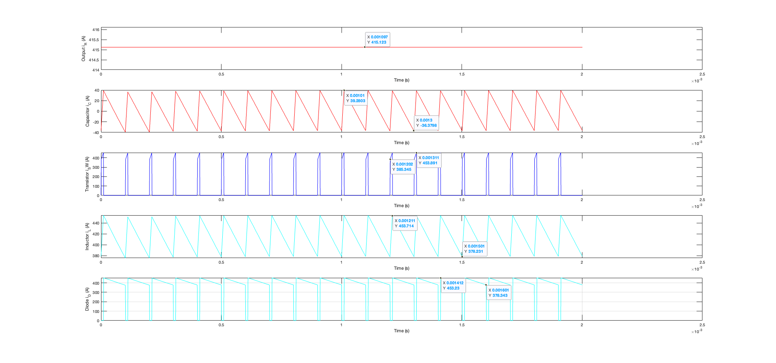

Comparing these values to the analytically ones gives us a percent error of 0.14% which means the circuit should be incredibly efficient since the efficiency of the circuit was around 1.0106. This might be due to an indexing error since the efficiency is over the limit of 1.00. Taking a look at the graphs, we see that the inductor current is periodic which is what we want and the output current is stable at around 415 A. The inductor voltage is averaging to be 0 which is what is needed so that the voltage for the capacitor stays within the spec. Comparing to the light load spec, we see that the graphs have similar results however they are differing in magnitude. Our output ripple is much higher than before, this might be due to the fact that we are closer to the inductor value now and that is why we used this critical inductance to determine if the I_1 current would be zero or not. The efficiency for the light load was determined to be 0.9016 which is a much more reasonable answer than 1.01. The 0.90 efficiency rating shows that the values were determined properly and the circuit is dissipating the power correctly over ideal components.

# Conclusion

In this project, I simulated a buck converter to determine the individual currents and voltages for each component. The method used was a backwards euler integration to approximate the next value of the function using the previous value and a very small time interval so little change occurs. Additionally, the non-idealities of the transistor and diode were tried to account for but unfortunately the results came out very unexpected or rather incorrect. Rather than accounting for a switching supply of -3V and +2V, we were getting just a simple deduction of those values from the output voltages. This may have to due with the backwards euler coefficients changing while manipulating the KVL loop. Regardless of the conflict, the small voltage drop over the transistor and diode should not have such a enormous effect on the output of the 48V. Simulation of the circuit helped understand the importance of each component in the circuit and how each of them are related. The switching of the transistor and diode controls the max and mins of each of the components which allows the output voltage to reach the needed 48 V. Sometimes these converters are connected further to a linear regulator so that the deltaV for the spec is even less and can be dissipated as low heat.